Lec. 2 crown & bridge

Components of the bridge:

1. Retainer: It's the part that seat over (on or in) the abutment tooth, connecting the pontic to the abutment, it is either major or minor retainer, & it could be crown, inlay, post & core.

2. Pontic: It is the suspended member of fixed partial denture that replaces the missing tooth or teeth, usually it occupies the position of the missing natural tooth.


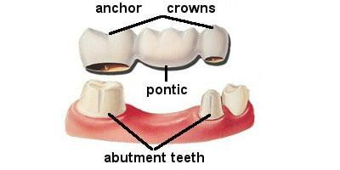

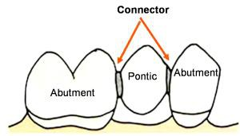
3. Connector: It is a Part of F.P.D that join the individual components of the bridge together (retainer& pontics), which could be fixed (rigid) or movable (flexible) connector. When the retainer is attached to a fixed connector it's called a major retainer, but when it is attached to a flexible [movable] Connector it is called a minor retainer.

Definitions (terminology)


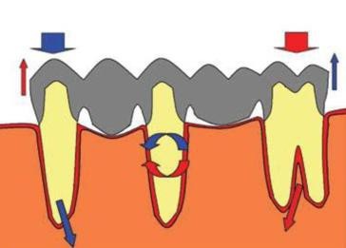
Abutment: a tooth to which a bridge attached.

Span: is the space between natural teeth that is to be filled by pontics.

Pier: is an abutment standing between two abutments & supporting two pontics, each pontic being attached to further abutment.

1

Unit: when applied to bridgework, means either a retainer or a pontic; (thus bridge
replace premolar & use two abutments may have referred as three-unit bridge).

Path of insertion: An imaginary line along which the restoration can be inserted and removed without any interferences or causing lateral force on the abutment.


Wing: is a term sometimes used for a minimum preparation retainer.

A. Depending on material used:
1.cast metal FPD (high Nobel, low Nobel and non-Nobel alloy).
2.metal ceramic FPD.
3.all ceramic FPD.
4.resin veneered FPD.

B. Depending upon location:

1.anterior bridge.

2.posterior bridge.

C. Depending on number of teeth:

1.two units FPD.

2.three units FPD.

D. Depending upon tooth reduction:

1.conventional bridge: where substantial tooth preparation is necessary for the abutment teeth.

2.minimal preparation bridge (adhesive, acid etched, resin bonded bridge): such bridge is designed so that to be luted to the unprepared or minimum preparation surface of abutment teeth permanently by acid etching of enamel with some type of resin bonding agent, Like: The Maryland Bridge.

2


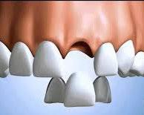

ADVANTAGES

1. Minimal tooth structure needs to be removed. In general, the preparation is confined to enamel only.

2. Pulpal trauma is minimized.

3. There is no need to make preparations parallel to each other

4. Anesthesia is not routinely used during tooth preparation.

5. The margin of the prosthesis is placed supra-gingivally, so periodontal irritation is kept to a minimum.

6. Impression making is simplified due to the supra-gingival margins.

7. Provisional restorations is usually not required other than in selected patients.

8. Chair time is significantly reduced compared to conventional fixed prosthodontics.

9. The restoration can be re-bonded.

DISADVANTAGES

1. The longevity of the prosthesis is less than for conventional prostheses.

2. Space correction is difficult with resin-retained FPDs. When the pontic space is greater or less than the dimensions of a normal tooth, achieving an esthetic result with this restoration is difficult.

3. Good alignment of abutment teeth is required because the prosthesis' path of insertion is limited by potential penetration of the enamel thickness.

4. The length of span is limited to one pontic because of the leverage forces.

3

5. Occlusal forces on the pontic of small posterior bridges encourage
tilting of the abutment tooth.

3.hybrid bridge: a bridge with a combination of conventional and minimum preparation bridge.

4.implant supported fixed partial denture: it is a bridge that is totally supported to implant fixer, usually not attached to adjoining natural teeth:

*cannot be removed by the patient, only dentist can remove it.

*can be removed by the patient for cleaning or any other reason.

5.removable bridge: it is a bridge that is totally supported by teeth and should not be confusing with removable partial denture, they either:

*cannot be removed by the patient, but can easily remove by dentist, purpose: to overcome problem associated with long span FPD.

*can be removed by the patient for cleaning or any other reason. They were developed by Andrew, hence they are known as Andrews bridge system, purpose: indicated for edentulous ridges with sever vertical defect. The prosthesis fixed component and removable component.

E. Depending upon the connector (basic bridge designs):

1. fixed-fixed bridge.

2. fixed-movable bridge.

3. cantilever bridge.

4. spring cantilever bridge.

5. compound bridge.

NOTE: The basic bridge design are types of bridge according to connector type.

1. Fixed-fixed bridge:

*It has rigid connector at both end of the pontic.

*It provides maximum retention & strength.

* It is the most practical design for long span bridge.

* All the retainers in this type are major retainer & require extensive preparation reduction of the abutment.

4

* Should have one path of insertion (the preparations of both abutments need
to be parallel).

* The entire occlusal surface of both abutments should be covered with the retainer (occlusal forces direct on the unprepared area which lead to depress tooth & break connector).

* All the retainers should have approximately the same degree or amount of retention; this to reduce the risk that the force applied will dislodge the weak retainer & leave the bridge suspended).

* More reduction means more destruction of tooth structure & trauma to pulp.


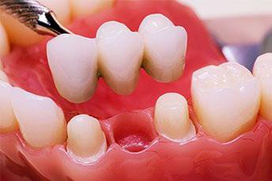
* Abutment teeth are splinted together (adequate in case of mobile teeth).

* This type is cemented as one piece.

2. Fixed- mobile design:

* Have rigid connector (major) at the distal end of pontic & mobile (minor)
connector mesially.

* More conservative to tooth structure than fixed-fixed design, because minor retainer needs less reduction.

* It allows minor tooth movement (lateral & vertical).

* Limited to one missing tooth (length of span limited).

* Parts of the bridge can be cemented separately.

* Lab. Construction is complex & difficult.

* Preparation of abutment does not need to be parallel.

5

* It is indicated to be used in:

1. Divergent abutment teeth (not parallel).

2. Whenever a pier abutment is present (complex bridge).


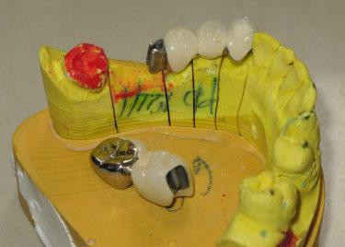
3. For esthetic consideration (class III inlay on distal of canine).

3. Cantilever bridge:

FDPs in which only one side of the pontic is attached to a retainer are referred to as cantilevered.

a. Simple cantilever:

* It provides support pontic at one end only

* Pontic may attach to one or two retainer

* Abutment tooth either mesial or distal to the span

* It is the most conservative design where one abutment tooth is needed

* Most successful design in replacement of lateral incisor using the canine as abutment when the occlusion is favorable

* The design also can be used to replaced upper or lower first premolar &
second molar

6


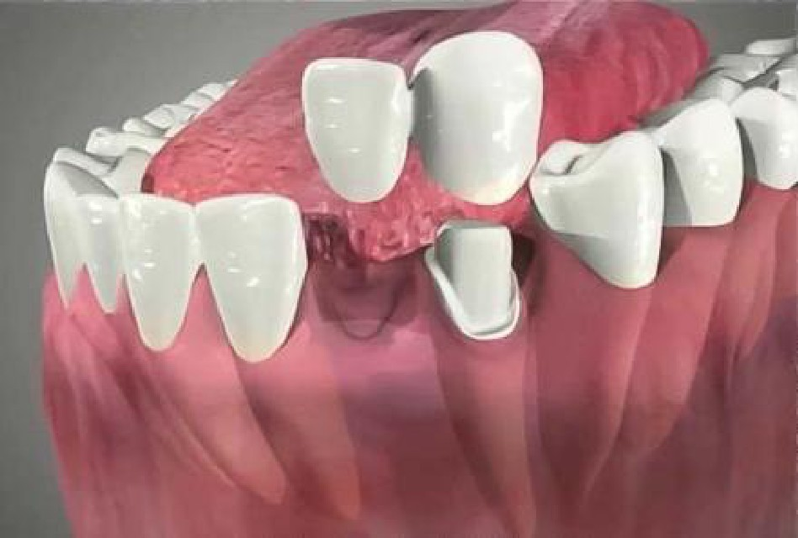

b. Spring cantilever

* The pontic attach to a long metal arm run into the palate & terminate with rigid connector on the palatal side of a single retainer on upper 4 or pair 4 & 5

* Abutment usually posterior (tooth need restoration is better to be used)

* The pontic is connected to the retainer by long flexible metal bar (arm)

* Contraindicated in V-shape palate & in lower arch

* It is indicated only for replacing missing upper incisor when:

- The adjacent teeth are sound

- In cases of midline diastema

- Spacing of anterior teeth

- Posterior teeth need crown

* Not advice for lower because:

- Un stability of the sub-mucosal tissue

- Potential for plaque & calculus deposition

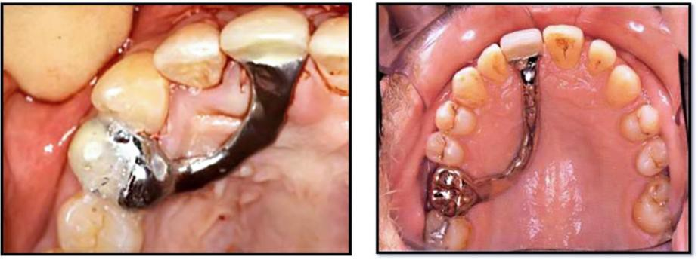

7

4. Combination designs (Complex or compound bridge)

It is a combination of two or more of the conventional designs incorporated in the general design of bridge, such as:

- Fixed-fixed with simple cantilever.


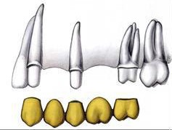
- Fixed-fixed with fixed mobile.

Benefits:
Should failure occur or repair work needed, only small parts of the whole bridge may have to be disturbed.
Simplify all the steps of construction.
Reduce strain on patient by several short visits that are comfortable than two
long visit.

Fixed Partial Denture (Bridge)
Purposes (Benefits) of fixed bridge
1. Correction of any abnormal oral condition
2. Restore mastication to full functional efficiency
3. Maintain the health of remaining dentition & prevent further injury
4. Restore appearance & esthetic
Indications
Local:
1) A bridge indicated whenever there are probably distributed healthy teeth that serve as abutments.
2) Tooth suitable for abutment which require cast restoration (the same tooth lie adjacent to edentulous space & suitable as abutment , bridge may be positively indicated)
3) Un favorable angulations of the teeth for removable prosthesis , when teeth
are badly tilted , then conventional chrome/ cobalt partial denture may be contraindicated
4) It is advisable to restore edentulous space with fixed rather than removable partial denture

8

F.P.D: force of occlusion transmitted to periodontium, to alveolar bone (natural)
R.P.D: force of occlusion transmitted to muco-periostium, to
underlying bone (which is not designed this function)

General:
1- Psychological: many patient cannot tolerate R.P.D. because they feel that is not part of them, while F.P.D. is usually rapidly tolerated as part of their natural arch
2- Systemic: for example epileptic patient ( attack of unconsciousness)
positively contraindicated for R.P.D due to fear of fracture inhalation, while F.P.D have adequate strength & retention
3- Orthodontic consideration : F.P.D indicated for the stabilization of an orthodontic result (e.g.: F.P.D used to replace missing lateral incisor after diastema between two centrals has been closed)
4- Speech: R.P.D. is bulky, thus may cause further difficulty in speech. While
F.P.D size is usually similar to that of the teeth it replace it and rarely cause difficulty in speech
5- Periodontal reason : when teeth are somewhat mobile , ideal way to achieve stabilization is by construction of fixed splint ( bridge):-
a) To prevent tooth movement (drifting)
b) Prevent over extrusion which may lead to loss of bony support
c) Ensure that the forces of mastication are eventually distributed over several teeth & avoid the overloading on periodontal tissue of the tissue which has been already seriously weakened by disease.

Contraindication
Local:
1- Absence of distal abutment
2- if there is considerable loss of bone in visible area of the mouth
3- when resistance to lateral movement is needed from contra-lateral teeth & soft tissue
4- in cases of long span
5- abutment related factor ( tooth not suitable as abutment : length, shape, caries, periodontal support)

General
1- Uncooperative patient: difficulty to achieve satisfactory result if the patient uncooperative.
2- Social problem: ability of the patient to pay is very important. F.P.D. is more expensive than R.P.D., the patient must be given what he wants, & from what he is given, he can evaluate what he gain.
3- Occupation: boxers or hokey players are not advisable to use F.P.D. also pipe smokers (fracture of the bridge and abutments).
4- Poor oral hygiene: P.O.H positively contraindicated for F.P.D., P.O.H indicate bad attitude of patient toward dentistry, so it is better to get patient motivation toward oral hygiene before starting F.P.D.

9

5- Age: F.P.D preferable to be done after the age of 17-18 years of age especially to the posterior teeth because:-
Tooth has large pulp.
Teeth not fully erupted.
Gingiva teeth relation not complete.
Face and jaws are not fully grow.
Also F.P.D. is not indicated for elderly patient when there is lack of resilience in the periodontal membrane or abrasion which increases the size of occluding surfaces.

Advantage of bridge:
1) Improve appearance.
2) Improve masticatory function.
3) Improve speech.
4) Occlusal stability.
5) Periodontal splinting.
6) Restore occlusal vertical dimension.
Disadvantage of bridge:
1) Damage to the tooth & pulp.
2) Secondary caries.
3) Periodontal problem.
4) Cost.
5) Discomfort

THE END

10

