Lec.2 Endodontics

Endodontic Radiography

The dental radiograph allows indirect vision to the dentition and supporting structures, and provides standardization of intra canal procedures. As a result, radiographs are a very important aid for endodontic diagnosis and treatment.

Information gained from the radiograph
1- The crown and pulp anatomy
2- Hard tissue alterations in the tooth (sclerosis or resorption)
3- Number, size, location and direction of the roots
4- Estimation of the working length
5- Related anatomical structures as mental foramen, maxillary sinus etc...
6- Confirm position of master cone
7- Evaluation of success of obturation
8- Instrument separations or perforations

Suggestions for good endodontic radiography
1- For periapical exposures the edge of the film is positioned parallel to and
near the incisal or occlusal surface of the teeth so that the tooth apices are
near the center of the film.

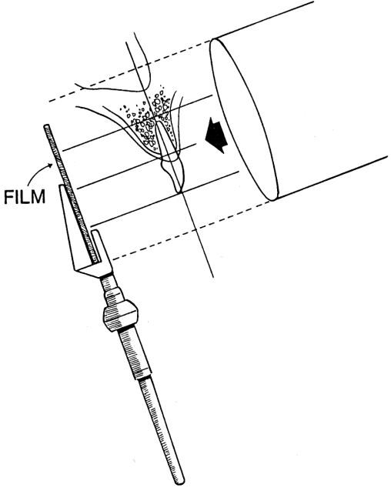
2- The plastic film holder facilitates standardization of a radiographic technique by aiding in film positioning and preventing movement of the film during exposure.

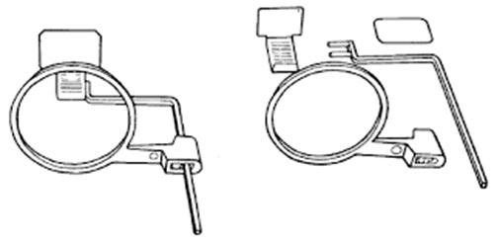

3- Because of the angle of the hard palate the films that are held by the finger usually show maxillary molars with short buccal roots and very long palatal root.

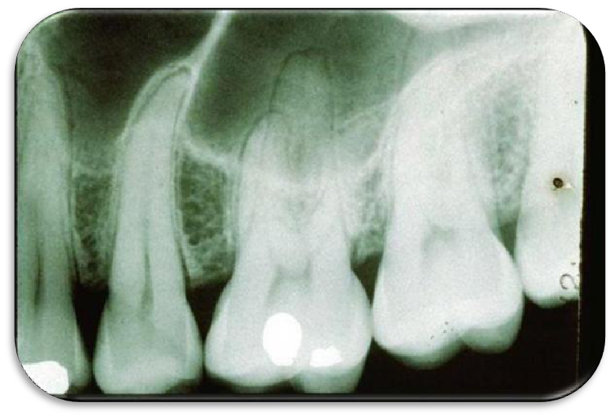

Buccal object rule
When treating premolars and molars, it is often difficult to recognize
radio graphically which canal is nearer to buccal side. When the exposure is done to a multi canaled tooth, the canals may be superimposed and difficult to differentiate them. If the x-ray cone is deviated mesially or distally with a given angle the roots will separate in the film. Therefore, when the cone is
moved distally the buccal canal appears mesial to the lingual or palatal canal and when the cone is moved mesially the buccal canal appears distal to the lingual or palatal canal.

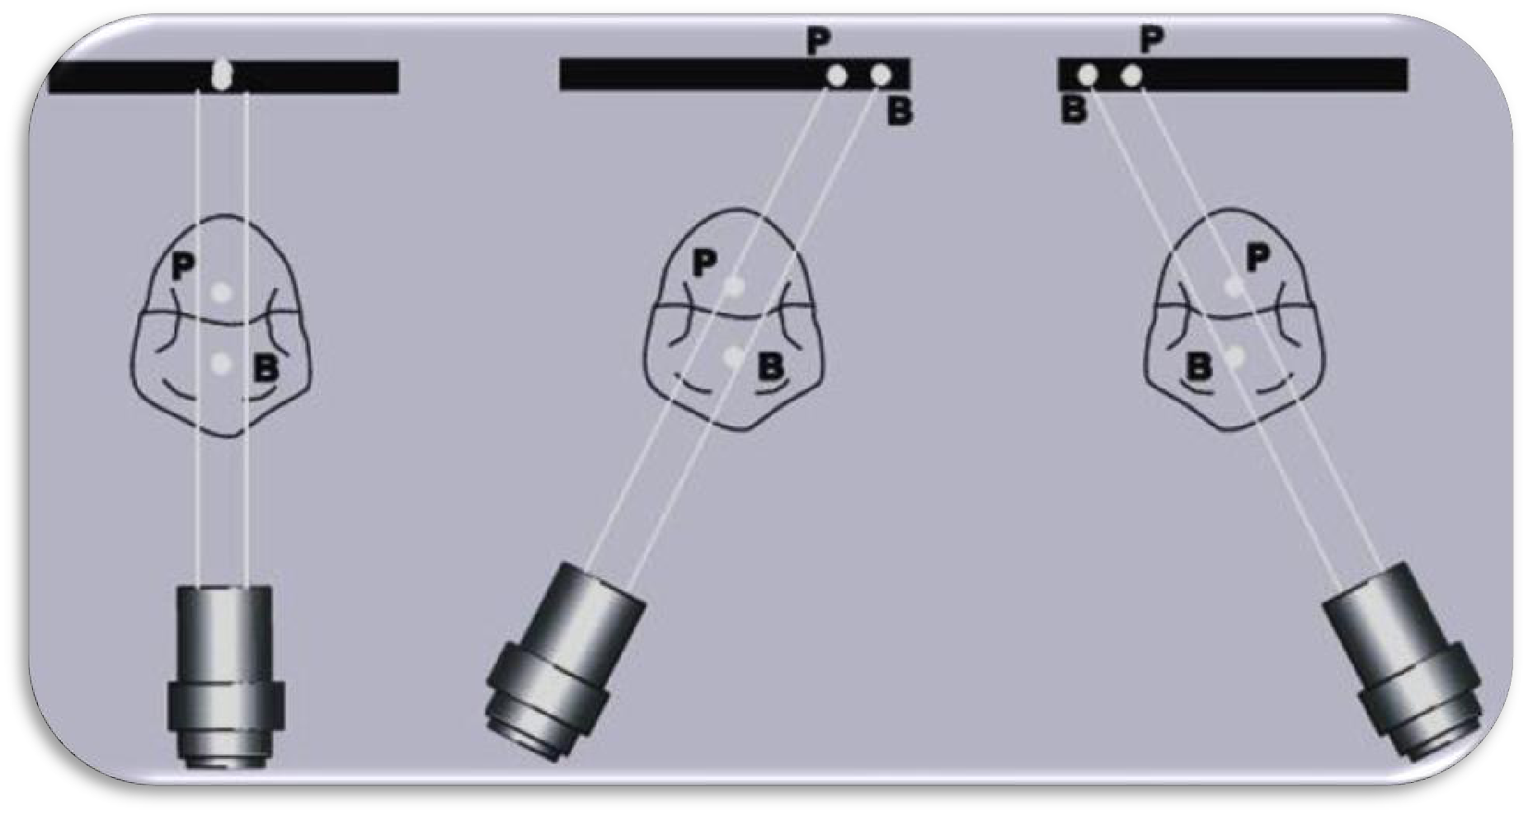

Digital radiography:
Digital radiography uses no x-ray film and requires no chemical
processing. Instead, a sensor is used to capture the image created by the radiation source. This sensor is either directly or wirelessly attached to a local computer, which interprets this signal and, using specialized software, translates the signal into a two-dimensional digital image that can be displayed, enhanced, and analyzed.

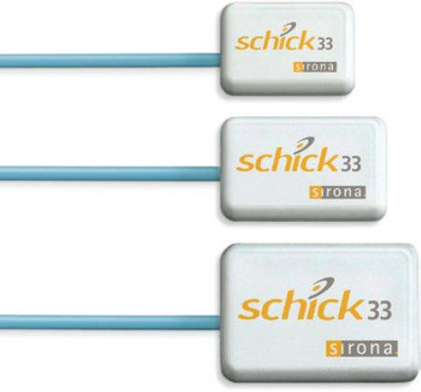

3 different sensor sizes.
Advantages of digital radiographs over conventional radiographs:

• Lower radiation doses.
• instant viewing.
• convenient manipulation.
• efficient transmission of an image via the Internet.
• simple duplication.
• Easy archiving.
• the image can even be colorized, a useful tool for patient education

Cone-Beam Computerized Tomography (CBCT):
The radiation source of CBCT is different from that of conventional two-
dimensional dental imaging in that the radiation beam created is conical in shape. Also, conventional digital dental radiography is captured and interpreted as pixels, a series of dots that collectively produces an image of the scanned structure. For CBCT, the image is instead captured as a series of three-dimensional pixels, known as voxels. Combining these voxels gives a three-dimensional image that can be “sliced” into various planes, allowing for specific evaluations never before possible without a necropsy.

Compared with two-dimensional radiographs, CBCT can clearly visualize the interior of the cancellous bone without the superimposition of the cortical bone. Studies show that CBCT is much more predictable and efficient in demonstrating anatomic landmarks, bone density, bone loss, periapical lesions, root fractures, root perforations and root resorption.

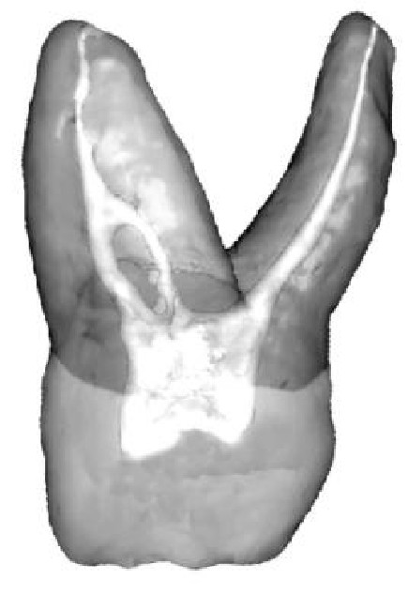
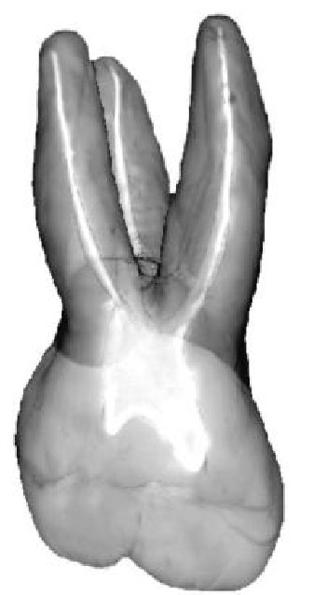
Factors affect the quality of radiograph
- Radiolucent rubber dam frames don’t interfere with taking radiograph, metal frames may mask important structures
- A quick automated processing technique offers a clear radiograph. It maintains a water bath heated by a thermostatically controlled heater that maintain the developer and fixer at 100F,, so for 5-10 sec. rinsed with water and then placed in fixer until it becomes clear(15-20 sec.)
- All endodontic radiographs must be dated and mounted in chronological sequence to allow for immediate reference
- Film magnification is essential to see clearly detailed structures in the film. Today, digital radiographs allow detailed picture that can be zoomed in clearly.

Pain Control in Endodontic
The pain reaction threshold (PRT) is defined as that point at which a person will feel the pain. With endodontic therapy the response to stimulation is significantly increased. Factors that lower the PRT include:
1- Presence of pain in the beginning of treatment.
2- Fatigue.
3- Fear and anxiety.
By increase of pain sensation, blood level of catecholamine
suddenly elevates with an increase in blood pressure and heart rate. This
might induce fainting, angina pectoris, asthma and psychiatric reactions.
To reduce the possibility of such conditions happening the anesthesia has
to be introduced slowly and in supine position.

Local anesthesia
It is the temporary loss of sensation or pain in certain part of the body produced by a topically applied or injected agent without depressing the level of consciousness. Prevention of pain during dental procedures
eliminates fear and anxiety.
Knowledge of the anatomy prevents problems during anesthetic injection as muscle trismus, hematoma and intravascular injection.
There are 2 general types of local anesthetic chemical formulations:
1- Esters as procaine, benzocaine.
2- Amides as lidocaine, mepivicaine, prilocaine and articaine.
Local anesthetics are vasodilators, absorbed in the circulation and have a systemic effect. Vasoconstrictors in the local anesthetic constrict the blood vessels to lower the absorption of the local anesthetic agent into the blood stream, to prolong the anesthetic effect in the area and decreasing the possibility of toxicity. It may be used to stop bleeding by infiltration of few drops in the bleeding area.
The condition of patients with hyperthyroidism, cardiovascular disease, diabetes and having drugs as tricyclic antidepressants and MAO inhibitors need a consultation with the physician before injection with a local anesthetic having vasoconstrictor.
If the local anesthetic is injected in an infected area, its onset will be delayed. The inflammatory process in an area of infection lowers the pH of the extracellular tissue from its normal value to 5-6 or lower. This
low pH inhibits anesthetic action because little of the free base form of the anesthetic is allowed to cross into the nerve sheath to prevent conduction of nerve impulses. Inserting a needle into an active site of infection may spread the infection.
Topical anesthetic
It is effective to minimize surface discomfort of injection of the needle (2-3
mm in depth). This anesthetic is composed of benzocaine (up to 20%) or lidocaine as solution or ointment (5%) or spray (up to 10%).

Techniques for mandibular anesthesia
1- Inferior alveolar nerve block.
The site of deposition is near the mandibular foramen before the entry of the inferior alveolar nerve. It provides pulpal anesthesia of all mandibular teeth in the quadrant, along with buccal soft tissues and bone anterior to the mental foramen and the lingual soft tissues and anterior two-thirds of the tongue. (Fig.1).

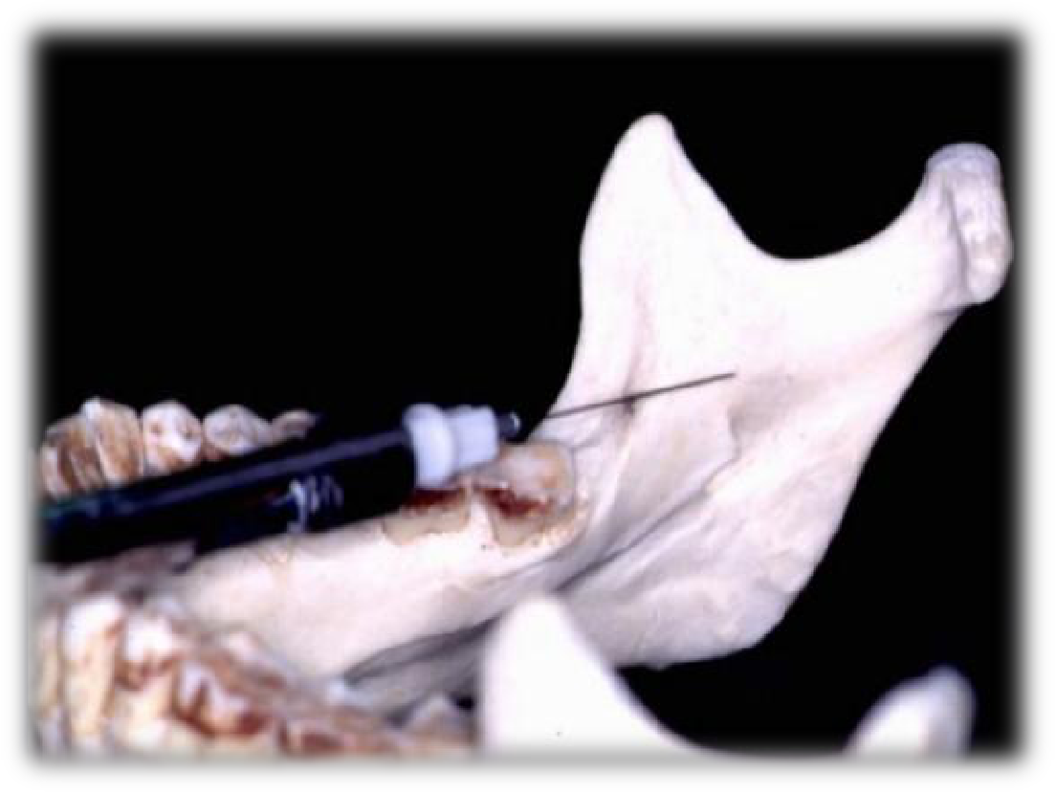

Figure1: Inferior alveolar nerve block.

2- The Gow-Gates mandibular nerve block.
The site is the lateral aspect of the neck of the mandible condyle. It is a V3 nerve block anesthetizing all the mandibular teeth in the region with the buccal and lingual soft tissues (Fig.2).
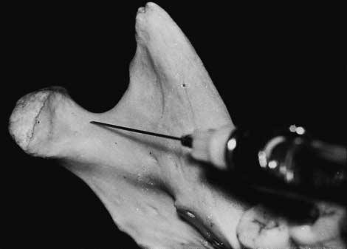
Figure2: The Gow-Gates mandibular nerve block
.

3- The Akinosi-Vazirani nerve block (Closed-Mouth Technique): The site is the height of the muco gingival junction of the maxillary third molar near the maxillary tuberosity. It is a V3 nerve block anesthetizing all the mandibular teeth in the region with the buccal and lingual soft tissues. This is used where there is limited mouth opening (Fig3).

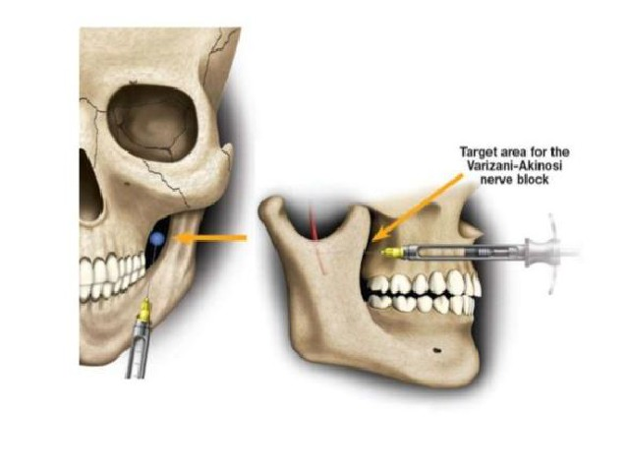
Figure3: The Akinosi-Vazirani nerve block.

4- The Incisive nerve block.
The site is buccally between the mandibular two premolars (Fig 4). The INB is an underused technique, but one that provides pulpal anesthesia to the five mandibular anterior teeth on a very reliable basis, even in the presence of infection. Soft tissue anesthesia of the lower lip, skin of the chin, and buccal soft tissues anterior to the mental foramen is achieved
100% of the time. Local anesthesia is infiltrated outside the mental foramen and then, with the use of finger pressure, forced into the foramen and mandibular canal where the incisive nerve is located. Pressure should be applied to the area for at least 1 minute, preferably 2 minutes, following deposition of the anesthetic. Lingual soft tissues, including the tongue, are not anesthetized in the incisive nerve block. Should lingual soft tissue anesthesia be required for placement of a rubber dam clamp, it can be achieved painlessly by advancing the needle through the already anesthetized buccal papilla toward the lingual while depositing small volumes of local anesthetic
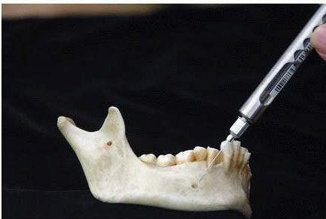
Figure 4: The Incisive nerve block.

Techniques for maxillary anesthesia

Although profound anesthesia of maxillary teeth is normally easier to obtain, problems, if they occur, usually do so following the administration of an infiltration injection to a central incisor, canine, or molar. The apex of the central incisor may lie under the cartilage of the nose, making infiltration less effective (as well as more uncomfortable). Canines that have longer than usual roots may not be anesthetized when the anesthetic is deposited below the apex (needle is not inserted far enough). Infiltration anesthesia of maxillary molars will fail in situations where the palatal root flares greatly toward the midline of the palate. Most local anesthetics infiltrated into the buccal fold will not diffuse far enough toward the midline to provide adequate pulpal anesthesia in this situation. Additionally, where periapical
infection is present, the success rate of injected local anesthetics is diminished, sometimes considerably. Fortunately, maxillary anesthesia can readily be achieved through the administration of nerve blocks. Three nerve blocks, the posterior superior alveolar (PSA), middle superior alveolar (MSA), and anterior superior alveolar (ASA, “infra orbital”), successfully provide pulpal anesthesia to maxillary teeth, even in the presence of infection.

1-The posterior superior alveolar nerve block.

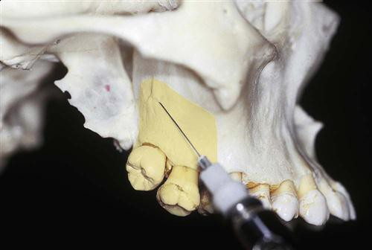
The site is in buccal fold of the maxillary 2nd molar. It anesthetizes the maxillary molars and buccal soft tissues.

Fig 5: Target area for the posterior superior alveolar nerve block.

2-The middle superior alveolar nerve block.

It anesthetizes the maxillary premolars and the site of injection is in the
buccal fold of the premolars.
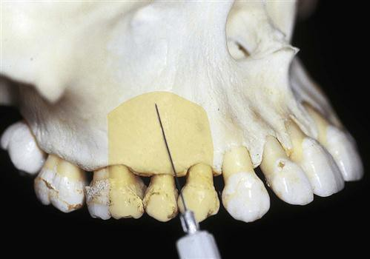
Fig. 6: Target area for the middle superior alveolar nerve block.

3- The anterior superior alveolar nerve block.

The site is the buccal fold of the first maxillary premolar and aimed
at the infra orbital foramen. The areas anesthetized are the anterior teeth and premolars with overlying soft tissues.

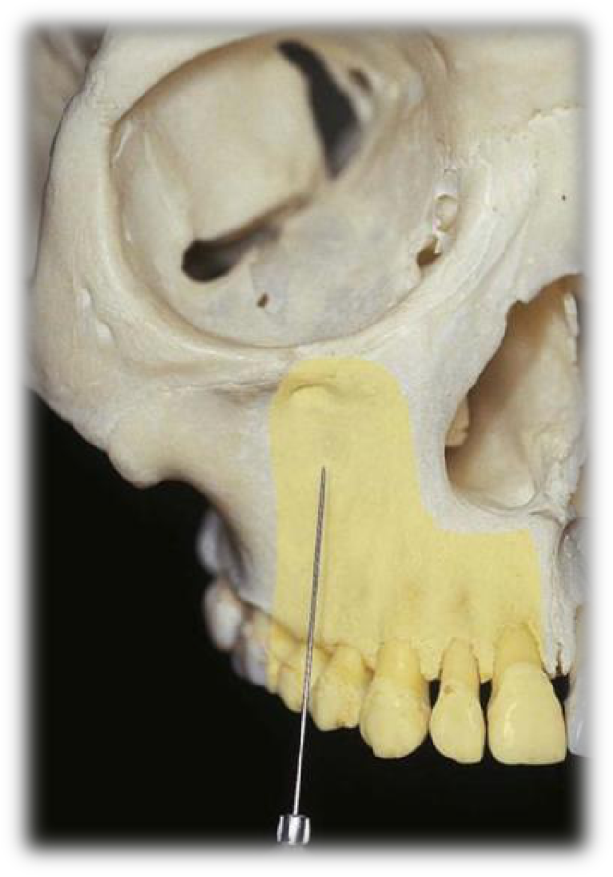

Fig. 7: Target area for the anterior superior alveolar nerve block.
Supplemental injection techniques
1- Periodontal ligament (PDL) injection.
This technique is used when no other technique can be used. The needle is
inserted between the tooth and PDL with bevel of needle toward the root. Anesthetic solution of 0.2 ml is placed per root. Onset of anesthesia is immediate but duration is variable.

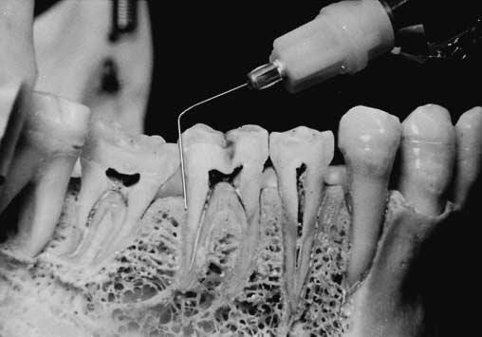

Fig.8: Periodontal ligament (PDL) injection.

2- Intra osseous anesthesia.
Local anesthetic is directed into the bone surrounding the root. A small perforation is made in the cortical plate of bone with a small bur and the needle is inserted to introduce the LA.
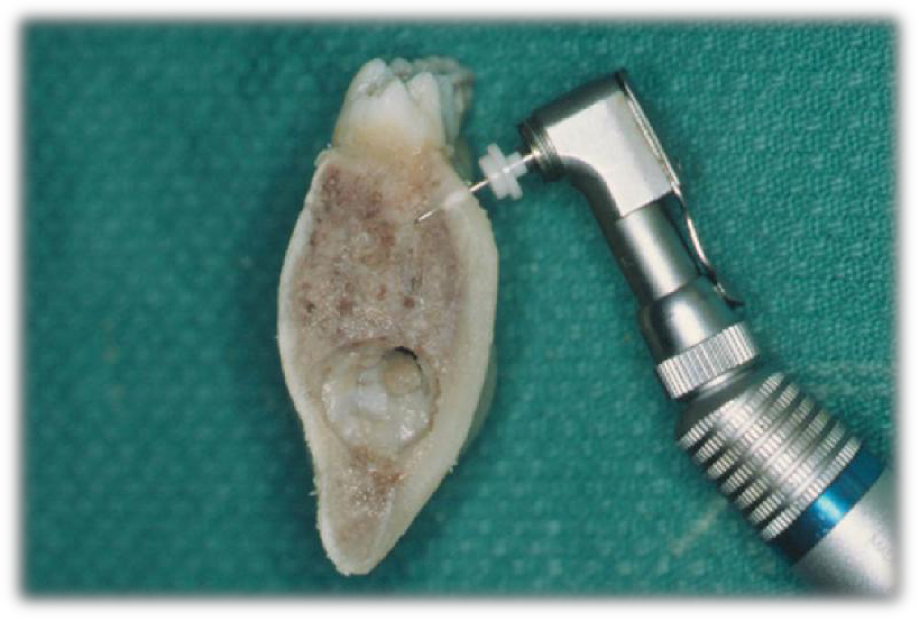
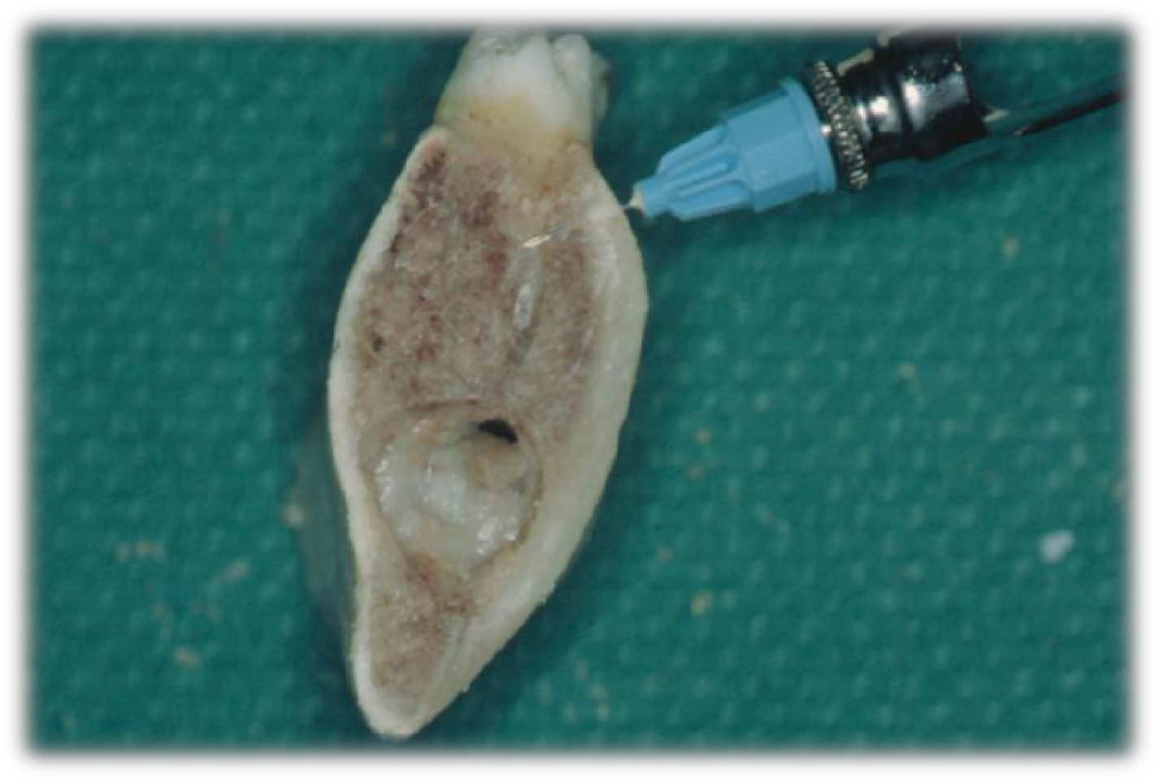

A

B

Fig.9: A. perforation is performed mesial or distal to the tooth. B. After removal of the perforator, the injection needle is introduced to deliver local anesthetic into periradicular
medullary bone.

3- Intrapulpal anesthesia.
When full anesthesia is not gained by other techniques, intrapulpal approach is used. The needle is inserted directly in the pulp and LA introduced with force. Onset is immediate.
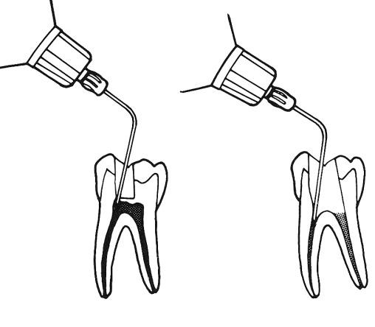

A B

Fig. 10: Intrapulpal pressure anesthesia with lidocaine. A, Coronal injection through pinhole opening in dentin. B, Pulp canal injection for each individual canal. Needle is inserted tightly and one drop of solution is deposited.

RUBBER DAM APPLICATION

The importance and purposes of the dam are:

1. It provides a dry, clean, and disinfected field.
2. It protects the patient from the possible aspiration or swallowing of tooth and filling debris, bacteria, necrotic pulp remnants, and instruments or operating materials.
3. It protects the patient from rotary and hand instruments, drugs, irrigating solutions, and the trauma of repeated manual manipulation of the oral soft tissues.
4. It is faster, more convenient, and less frustrating than the repeated changing of cotton rolls and/or saliva ejectors.
Methods of Rubber Dam Placement: Method I: Clamp placed before rubber dam :

• Select an appropriate clamp according to the tooth size.
• Tie a floss to clamp bow and place clamp onto the tooth.
• Larger holes are required in this technique as rubber dam has to be stretched over the clamp. Usually two or three overlapping holes are made.
• Stretching of the rubber dam over the clamps can be done in the following sequence:
– Stretch the rubber dam sheet over the clamp
– Then stretch the sheet over the buccal jaw of the clamp and allow to settle into place beneath that jaw
– Finally, the sheet is carried to palatal/lingual side and released.
This method is mainly used in posterior teeth in both adults and children except third molar.

Method II: Placement of rubber dam and clamp together:

• Select an appropriate clamp according to tooth anatomy.
• Tie a floss around the clamp and check the stability.
• Punch the hole in rubber dam sheet.
• Clamp is held with clamp forceps and its wings are inserted into punched hole.
• Both clamp and rubber dam are carried to the oral cavity and clamp is tensed to stretch the hole.
• Both clamp and rubber dam is advanced over the crown. First, jaw of clamp is tilted to the lingual side to lie on the gingival margin of lingual side.
• After this, jaw of the clamp is positioned on buccal side.
• After seating the clamp, again check stability of clamp.
• Remove the forceps from the clamp.
• Now, release the rubber sheet from wings to lie around the cervical margin of the tooth.

Method III: Split dam technique:

In this method rubber dam is placed to isolate the tooth without the use of rubber dam clamp. In this technique, two overlapping holes are punched in the dam. The dam is stretched over the tooth to be treated and over the adjacent tooth on each side. Edge of rubber dam is carefully teased through the contacts of distal side of adjacent teeth.
Split dam technique is indicated to isolate anterior teeth when there is insufficient crown structure or when isolation of teeth with porcelain crown is required. In such cases placement of rubber dam clamp over the crown margins can damage the cervical porcelain.

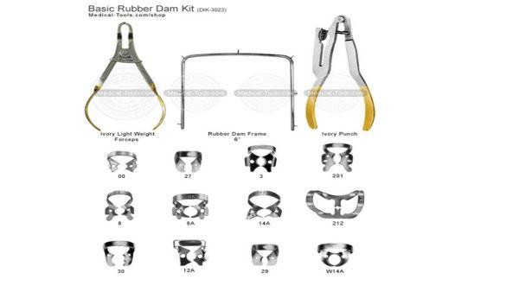

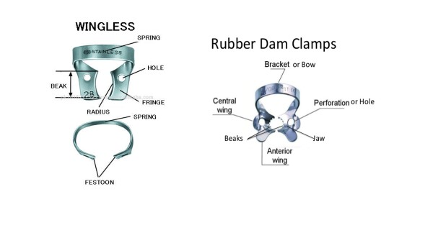

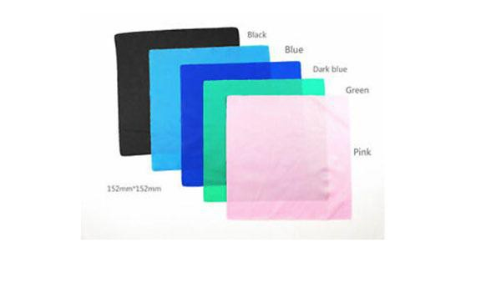

16

