Lec. 3 Crown & Bridge

Clinical consideration for bridge design

A-Abutment: is a tooth or portion of a tooth that used for the support and / or retain a

fixed bridge or part of the bridge, to which a retainer is connected cemented. All forces that would be normally absorbed by the missing tooth are transmitted through the pontic, connector and retainers to abutment teeth. The abutment teeth must withstand forces normally directed to the missing teeth, in addition to usually forces applied to the abutment teeth, therefore the choice of abutment is important because it has to withstand the forces acting on it and on the pontic, So the abutment teeth should be carefully evaluated by the clinician.
Requirements of abutment teeth

1. Abutment must withstand the forces normally directed to missing teeth whenever possible the abutment should be vital tooth.
2. A tooth that has been endodontically treated and symptomatic with radiographic evidence of good seal and complete obturation of the canal can serve as abutment (post and core for retention and strength).
3. The supporting tissue surrounding the abutment teeth must be healthy and free of inflammation.
4. The abutment teeth should not exhibit any mobility, since they will be carrying an extra load. Sever uncorrectable, periodontal disease is contraindicated for F.P.D.

EVALUATION AIDS
- CLINICAL EXAMIATION USING EXAMINATION TOOLS
- VITALITY TEST
- RADIOGRAPHS
- DIAGNOSTIC CASTS
- PERIODONTAL PROBE

Evaluation of abutment
Factors related to tooth abutment

1. Health of abutment:
*a sound abutment tooth allows ideal type of preparation. Caries tooth may be used as abutment provide that caries is removed the pulp protected and the tooth is restored to its original form by suitable filling material.

*If the caries far away from margin and small and the retainer design will extend
beyond the caries area, cement or resin can't be used in state of metal.
*extensive caries need extraordinary filling technique and preparation to conserve and support remaining tooth structure.
*non-vital teeth can be used only after endodontic treatment.

2. shape
Some teeth have conical, peg, bulbous or tapered crown form that interferes with the preparation parallelism, necessitating full coverage crowns to improve aesthetic and retention. Teeth like Peg laterals, Anterior teeth with poorly developed cingulum and short proximal walls, Mandibular premolars with poorly developed lingual cusps and short proximal surface, and Thin incisors

3. Crown length
*the abutment teeth must have sufficient crown length occluso cervically to achieve adequate retention.
*full coverage restoration and crown lengthening are considered with short clinical crowns to ensure adequate retention.

4. size of crown: it determines the type of retainer to be used.

5. axial relation ship

* rotation, tilting, overlapping, mal position might lead to decision of precluding of such tooth to be used as abutment (because rotation or torque can damage supporting structure or cause retainer to be loose).
* also it may indicate the use of specific retainer (over reduction lead to weaken the tooth and endanger pulp health).
* rotation lead to either increase or decrease of space available for pontic (size of pontic planned).
Factors related to root and gingival periodontal complex

Condition of supporting tissue

*the supporting tissue surrounding the abutment teeth must be healthy and free from inflammation, the abutment teeth should not exhibit any mobility since they will be carrying extra load.
*the alveolar bone support is one of most important factor that aid to evaluate an abutment (the supporting alveolar bone must be healthy).
The root and supporting tissue should be evaluated for the following:

1. Crown-root ratio.

2. Root-configuration.

3. The root- surface area (periodontal ligament area).

1. Crown - root ratio: is a measurement of the length of tooth occlusal to the alveolar crest of the bone compare with the length of root embedded in the bone. The ideal crown-root ratio for a tooth to be used as a bridge abutment is 1:2, but it is rarely seen in practice, ratio of 1:1.5 or 2:3 is considered the optimum, and the minimum ratio acceptable for prospective abutment under normal circumstances is 1:1, Abutment tooth with this minimum ratio can be considered when the opposing tooth is prosthetic appliance, mobile or periodontally involved.


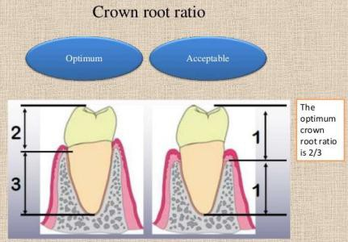

2. Root configuration and alignment:

*Roots that are broader labio-lingually than Mesio distally are preferable to roots that are round in cross section.

*Multi-rooted posterior teeth with widely separated roots will offer better support than roots that are converge (fuse or conical shape).

*Roots with some curvature in the apical third is preferable to that has nearly perfect taper. Well aligned abutment tooth will provide better support than malposed abutment.


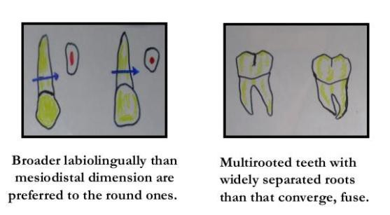

2. The root-surface area:

*the area of periodontal ligament attachment of the root to bone, it can be used as scale to measure abutment potency.

*The root surface area of potential abutment teeth must be evaluated when fixed prosthodontic treatment is planned. The root surface area (peri- cemental area) of the abutment teeth should be more or at least equal to the root surface area (peri-cemental
area) of the missing teeth being replace. This is called the Ante’s law.


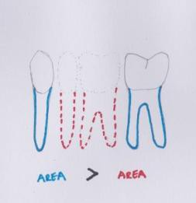


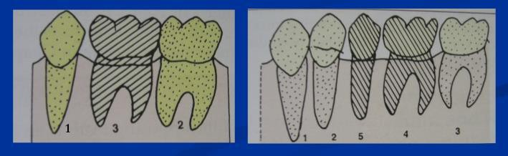


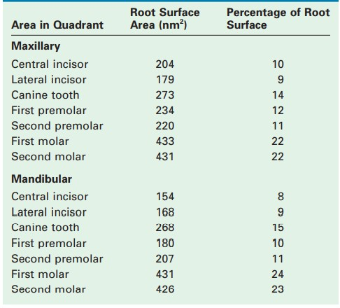

A n te ' s l a w
The root surface area of the abutment teeth (embedded in bone) (periodontal ligament area/pericemental area) must be equal or more than root surface area of teeth being replaced. Missing first molar alone or with second premolar, the root surface areas of both are equal to the root surface area of abutment (second & first premolar) ,however , replacing more than two posterior teeth ( molar and two premolars) generally unacceptable and risky because of insufficient abutment roots surface area. So that, One missing tooth can be successfully replaced if abutment teeth are healthy. If two teeth are missing, a FPD can probably replace the missing teeth but the limit is being approached. In selected case and in order to increase the capability of the bridge to withstand the loading force first premolar can be used as a secondary abutment
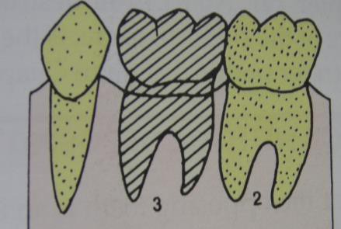

If three missing posterior teeth (first molar and the two premolars) OR When the root surface area of the teeth to be replaced by pontics surpass that of the abutment teeth, then a high risk or an unacceptable situation foe FPD is exists.

Biomechanical Considerations Fixed Partial Denture

A. Span Length: All FPDs flex slightly when subjected to a load; the longer the span, the
greater the flexing. it is not liner relationship but varies with cube of span length. Excessive flexing under occlusal loads may cause failure of a long-span FDP. It can lead to fracture of a porcelain veneer, breakage of a connector, loosening of a retainer, or an unfavorable soft tissue response and thus render prosthesis useless. Biomechanical Considerations include the role of the edentulous span dimension, pontic characteristics, the connecters or joints of the FPD., abutment tooth and the acting force (masticatory) on the success of the constructed bridge. The dimension of the span (MD length and OG height) were found to influence the number of the selected abutments , the type of retainers and the material from which the bridge will be constructed .In addition to the increased load placed on FPD by long span restoration ,longer span are less rigid, All F.P.D. flex slightly when subjected to a load, the longer the span, the greater the flexing. It is not linear relationship but varies with the cube of the length of the span. Thus if other factors being equal, if a span of single pontic is defected in a certain amount, a span of two similar pontics will have eight times as much, three pontics may move 27 times as much, this mean replacing three missing posterior teeth with F.P.D. rarely has favorable prognosis, especially in the mandibular arch (Treatment with R.P.D. or implant supported prosthesis). Also the thickness of FPD play important role on amount of flexing, unlike the length, Deflection of a fixed partial denture varies inversely with the cube of the occluso gingival thickness, this mean that a pontic with a given occluso-gingival dimension will bend 8 times as much if the pontic thickness is halved

When long span F.P.D fabricated:

*using double abutments to enhance retention and support for long span FPD.
*pontics and connectors should be made as bulk as possible to ensure optimum rigidity without harmful effect on gingival health.

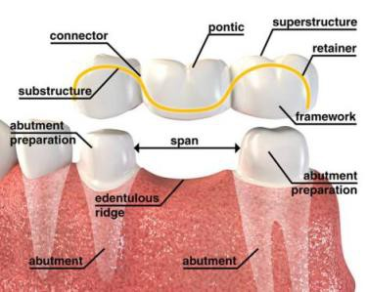

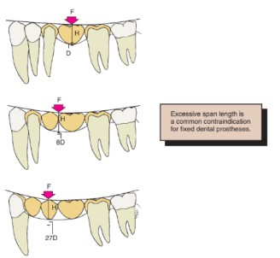
*the prosthesis should have made of a material that has high strength and rigidity.

B. Arch curvature: It has its effect on the stresses occurring in a fixed P.D, when the
pontic lies outside the inter-abutment axis line, the pontic act as a lever arm, which can produce a torque movement, this is a common problem in replacing the four maxillary incisors with F.P.D and its most pronounced in the arch that is pointed anterior

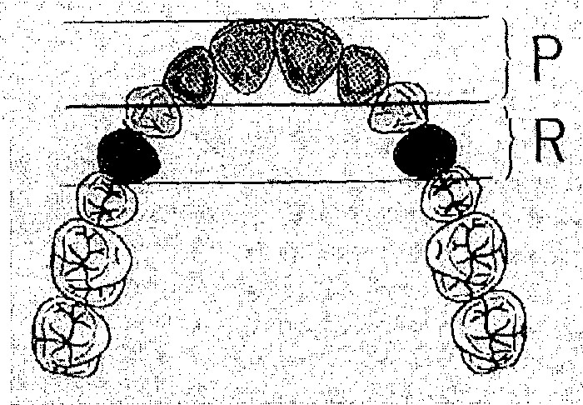

Using secondary abutment (1st premolar) to added retention in opposite direction from the lever arm and at a distance from the inter-abutment axis equals to the length of the lever arm.

C. Pier (intermediate) abutment:

Edentulous spaces can occur on both side of the abutment tooth creating alone free standing pier abutment. In such case, Forces transmitted to terminal retainers as a result of middle abutment acting as a fulcrum, causes failure of weaker retainer. To overcome such complication:

1) Such F.P.D. needs extremely retentive retainers.
2) Use of non-rigid connector.
3) When periodontal support is adequate, a much simpler approach would be to cantilever one segment of the bridge on one side of pier abutment.

Shillingburg and fisher (1973) recommended the use of non-rigid (movable “minor”)
connector to reduce this hazard:
*It is a broken stress mechanical union of retainer and pontic.

*It transfers shear stress to supporting bone rather than concentrating it in the connectors.

*It appears to minimize Mesio distal torqueing of the abutment, while permitting them to move independently.

*most commonly used non-rigid design T- shaped key that is attached to the pontic & a dovetail keyway placed in the retainer.

Location of the key and key way:

*should be placed in the middle abutment, placement on either of the terminal abutment can lead to pontic acting as a lever arm.

*keyway should be placed within the normal distal contours of pier abutment.

*key should be placed on the mesial side of the distal pontic.

Why keyway should be placed on the distal not on mesial of pier abutment?

Long axes of posterior teeth usually lean slightly in a mesial direction and about 98% posterior teeth tilt more mesially when subjected to occlusal forces. Therefore, if keyway is placed on the distal of pier abutment, then the mesial movement seats the key into the keyway more solidly. If placement of the keyway is on the mesial side, then it causes the key to be unseated during the mesial movement which in time can cause a pathologic mobility
in the canine or failure of the canine retainer.


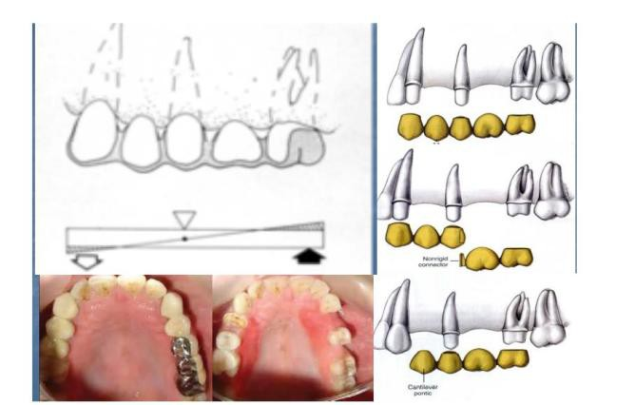

D. Tilted molar abutment: Tilted second molar lead to difficulty or impossibility to make
satisfactory F.P.D. because the positional relationship no longer allows for parallel path of insertion without interference with adjacent teeth.

To solve this problem:
1) Ortho treatment (up righting the tilted tooth).

2) Using proximal hall partial crown as a retainer on tilted molar abutment.

3) Using telescope crown and copping as retainer (A telescope crown and coping can be used as a retainer on the distal abutment i.e. full crown preparation with heavy reduction is made to follow the long axis of tilted molar. An inner coping is made to fit the tooth preparation and a proximal half-crown that will serve as a retainer for the FPD is fitted over the coping).
4) Non rigid connector is another solution to the problem.

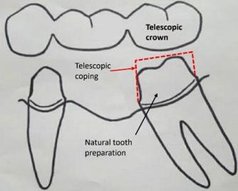


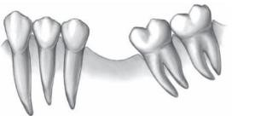

E. Evaluation of the path of insertion

Path of insertion should be check before imprint. Parallelometer – mirror can be used for such purpose especially in difficult case or in experience dentist, Parallelometer - mirror can easily spot the positional relationship of the prepared abutment.

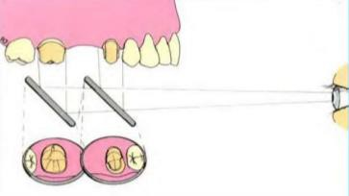

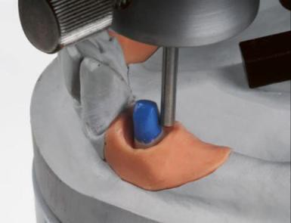

CANINE REPLACEMENT FIXED PARTIAL DENTURE
Fixed partial dentures replacing canines can be difficult because the canine often lies outside the inter abutment axis. The prospective abutments are the lateral incisor. usually the weakest tooth in the entire arch, and the first premolar, the weakest posterior tooth.

A FPD replacing maxillary canine is subjected to more stress than that replacing a mandibular canine since forces are transmitted outward (labially) on the maxillary arch, against the inside of the curve (its weakest point) ,while ,on the mandibular canine the forces are directed inward (lingually), against the outside of the curve (its strongest point).

THE END

